B-Trees

A B-Tree with minimum degree t has between t – 1 and 2t – 1 keys per node.
A node with k values has k + 1 children.
Height of a B-Tree: h ≤ log _{t} (n+1)/2

Insert

After inserting D, G, M, R, and W into a B-Tree with minimum degree 3, 2 to 5 values per node:

To Insert ‘J’:

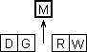
The root node must be split. Move the middle value up and create two children.

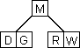
Set the child pointers.

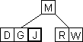
Place ‘J’ in the appropriate node.

After inserting B, H, S, U, and X:

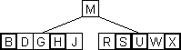

To Insert ‘A’:

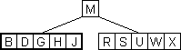
The node where ‘A’ must go is full, so it must be split.

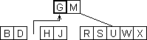
Move the middle value, G, up into its parent and create 2 children.

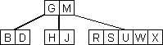
Set the children pointers.

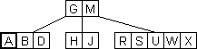
Place ‘A’ in the appropriate node.

To Insert ‘T’:

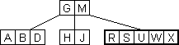
The node where ‘T’ goes is full, so it must be split.

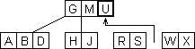
Move the middle value, U, up to its parent and create two children.

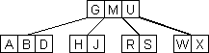
Set the child pointers.

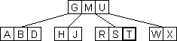
Place ‘T’ in the appropriate node.

Delete

The B-Tree Delete Algorithm has several different cases:

When deleting key k from a node x in a B-Tree with t = 3:

Case 1: If x is a leaf node, then the key can just be removed.

Example: Delete ‘B’

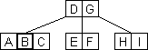
‘B’ is in a leaf node, so it can just be removed.

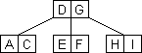

Case 2: If x is an internal node,
- If the key’s left child has at least t keys, then its largest value can be moved up to replace k.
- If the key’s right child has at least t keys, then its smallest value can be moved up to replace k.
- If neither child has at least t keys, then the two must be merged into one and k must be removed.

Example: Delete ‘U’

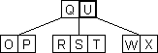
‘U’ is in an Internal Node.

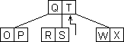
U’s left child has t keys, so the largest value, ‘T’, can be moved up to replace ‘U’ by Case 2a.

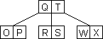
Example: Delete ‘I’

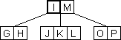
‘I’ is in an Internal Node.

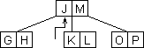
I’s right child has t keys, so the smallest value, ‘J’, can be moved up to replace ‘I’ by Case 2b.

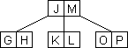

Example: Delete ‘U’

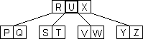
U’s children both have t – 1 keys.

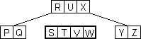
Merge the two children into one node.

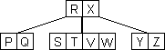
Remove ‘U’ and set the child pointer to the new node.

Case 3: If x has t -1 keys:
- If x has a sibling with at least t keys, move x’s parent key into x, and move the appropriate extreme from x’s sibling into the open slot in the parent node. Then delete the desired value.
- If x’s siblings also have t -1 keys, merge x with one of its sibling by bringing down the parent to be the median value. Then delete the desire value.

Example: Delete ‘L’

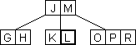
‘L’ is in a node with t – 1 keys.

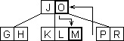
An immediate sibling has t keys, so move x parent key, ‘M’, into x. Move the sibling’s appropriate extreme, ‘O’, into the parent node. All by Case 3a.

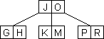
Now delete ‘L’ by Case 1.

Example: Delete ‘S’

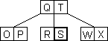
‘S’ is in a node with t -1 keys, and its siblings also only have t -1 keys.

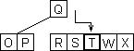
Choose one of the siblings and merge it with x by moving down the parent key to be the median for the new node, by Case 3b.

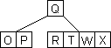
‘S’ can now be deleted by Case 1.

